# **The Ocean Cleaner**

## **Chapter 1: Introduction**

### **Presentation of the startup**

1. **Project introduction**

#### 2.1. Introduction

Every year, large quantities of plastic and other waste accumulate on the surfaces of lakes and oceans, creating major environmental and health concerns. These pollutants threaten aquatic life, disrupt ecosystems, and affect communities that depend on these water sources. Traditional cleanup methods are often expensive, time-consuming, and struggle to keep pace with growing pollution.

This project is our first step towards an innovative solution: a Minimum Viable Product (MVP) of an autonomous boat for collecting floating waste. However, it is important to note that the majority of the development was accomplished through virtualization. The project focused on designing and simulating the robot’s behavior and functionalities in a virtual environment, allowing us to validate key concepts and algorithms efficiently before real-world deployment.

The purpose of this report is to describe the development of the MVP, with particular emphasis on the virtualization phase. This includes the digital design and assembly of the boat, as well as the development and simulation of advanced features such as autonomous navigation, obstacle avoidance, and control logic using tools like ROS Noetic. In the realization phase, our work centered on implementing live video streaming, configuring and calibrating sensors, and conducting initial hardware tests. By sharing our approach and results, we aim to demonstrate the value of virtualization in prototyping complex robotic systems and highlight the potential for such technologies to positively impact aquatic environments.

#### 2.2 Objectives

The primary goal of this project is to develop a virtual prototype of an autonomous boat designed to collect floating waste from lakes and oceans. The focus is on utilizing simulation tools and software environments to validate the system’s core functionalities before any physical deployment. Additionally, the project includes the configuration of hardware equipment to bridge the gap between the virtual prototype and practical implementation.

The specific objectives are to:

* Design a mechanically stable dual-hull boat prototype.
* Simulate the boat’s navigation and obstacle avoidance using realistic scenarios.
* Integrate and test virtual sensors to evaluate the autonomous waste collection mechanism within the simulation environment.
* Create a web app for remote control and monitoring.
* Configure hardware components to prepare for real-world implementation

### **Existing solutions**

A diverse array of solutions have emerged over the years to tackle the persistent problem of aquatic waste collection. These approaches span from traditional manual cleanup operations and community-led initiatives to cutting-edge robotic systems and autonomous vehicles, reflecting both the urgency of the issue and the rapid evolution of technology in this field.

3.1 The Seabin

The Seabin Project provides a practical, stationary solution for collecting floating debris in marinas and docks. Below is a summary of its technical specifications and an explanation of its waste collection mechanism.

At its core, the Seabin uses a submersible pump to pull water and surface debris into a mesh basket. As the water gets filtered, the trash is trapped inside the basket while cleaner water flows back out into the harbor. The device holds up to 20 kg of waste and needs to be emptied by hand every so often. It works best in sheltered, powered locations and needs regular maintenance for optimal performance.

*Figure 3.1 The Seabin Project*

Unlike the stationary Seabin, my project introduces an autonomous, mobile boat that can travel across rivers and lakes, even in choppy or changing conditions. Thanks to its ability to navigate and adapt, it can reach trash in places where fixed devices can’t operate. This flexibility makes it a more versatile and responsive solution for real-time water cleanup.

3.2. The WasteShark Boat

WasteShark is an environmentally friendly aquatic drone designed to remove floating waste from urban waterways, ports, and marinas. Inspired by the whale shark’s filter-feeding technique, it is available in both remote-controlled and fully autonomous versions, providing a flexible solution for water surface cleanup.

WasteShark moves across the water’s surface, collecting floating debris into an onboard basket with a capacity of up to 200 liters. It can operate on preset routes or be steered manually, using sensors to avoid obstacles and optimize its cleaning paths. Once the basket is full, the waste is removed by hand and the device is ready to be used again.

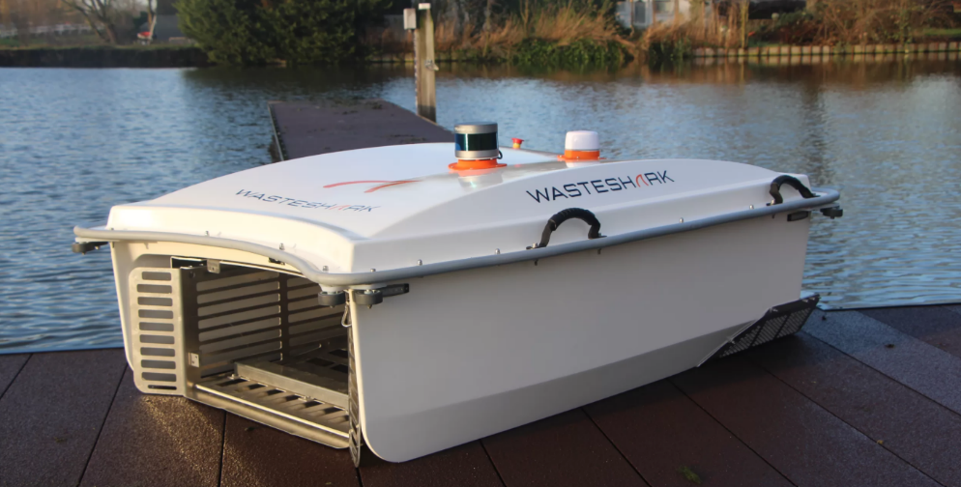

Figure 3.2. The WasteShark Boat

Compared to WasteShark, which is priced between $17,000 and $23,600 depending on the model, my autonomous boat offers a more compact, lightweight, and affordable solution at an estimated $5,000. Designed for easy navigation in rivers, lakes, and other natural environments, my boat can access areas that are harder to reach for larger devices, providing a more versatile and cost-effective option for real-time water cleanup.